Flow chart for if else statement

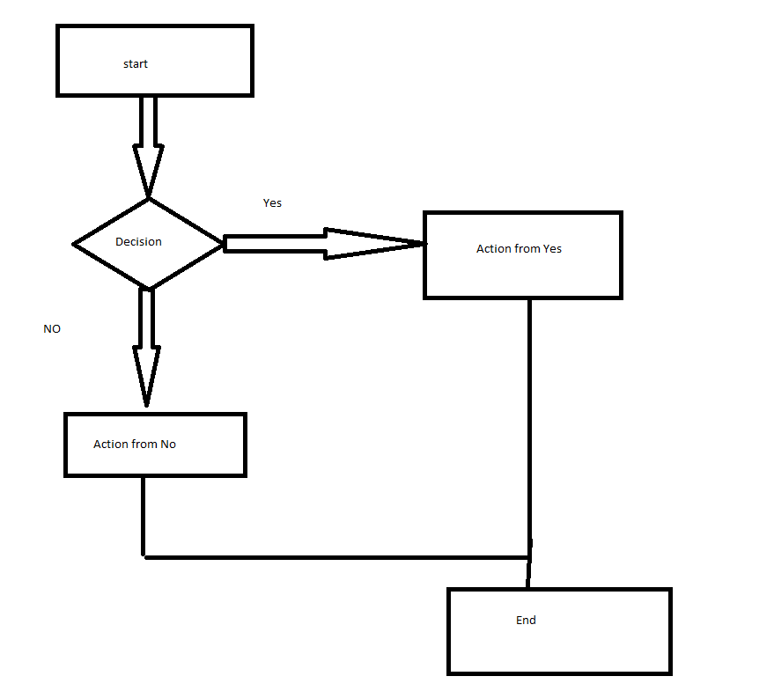
Note:
- Technically you only need an if statement (you do not need else)
- Everything inside the if statement will be indented. If you do everything correctly, it will be correctly indented for you
- If you have two choices, the other one will be “else”
- Else means “everything else”, therefore, it is very important that you don’t put a condition there
- If and else need to be together
- What if you have more than two choices? Use the keyword elif
- Elif and else will discard the other cases
- Else will follow the closest if
- #nested if statement–I can have an if statement inside and if statement
- # elif, else will follow the closest if
- # correct indentation is the key!!!

